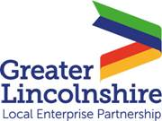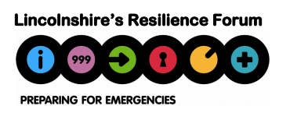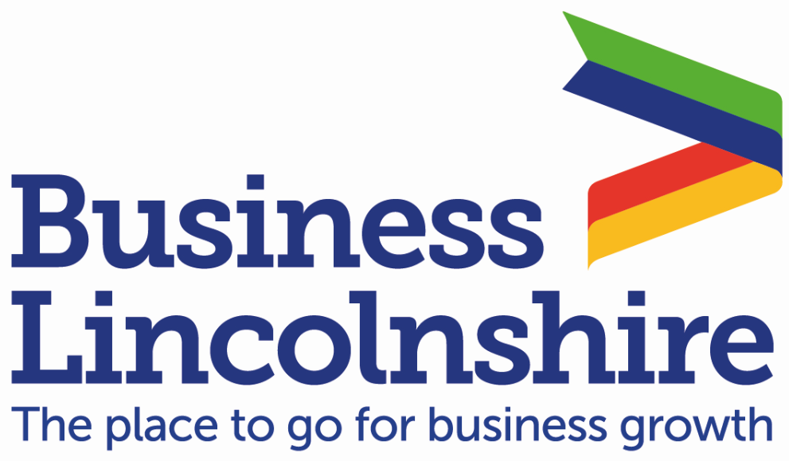
LRF Communications Briefing – Covid19
LRF Communications Briefing – Covid19
02 June 2021

LRFBIZ V63 – ECONOMIC RESPONSE & RECOVERY VERSION

Coronavirus Headlines

60 million doses of COVID-19 vaccine administered in UK
Over 60 million doses of the COVID-19 vaccine have been administered, with 37.9 million people in the UK receiving at least one jab and more than 22.6 million people receiving both doses.

Further information available here.

Vaccines highly effective against new variant after 2 doses
A new study by PHE shows for the first time that two doses of the COVID-19 vaccine are highly effective against the B.1.617.2 variant first identified in India, and we expect to see even higher levels of effectiveness against hospitalisation and death.

Further information available here.

Business & Economy
Take part in the Quarterly Economic Survey
This survey asks Lincolnshire businesses how the past 3 months compare to the previous period – covering aspects such as sales and orders, workforce cashflow, and confidence.
Each response helps paint a clear picture of Lincolnshire! More than 6,000 businesses nationally participate in the QES during each quarter. It takes just 3 minutes to complete and can be logged anonymously.

Visit LinkedIn or Twitter and follow the link.

Greater Lincolnshire LEP latest intelligence roundup headlines
Latest statistics on the claimant count* show that the number of people claiming across Greater Lincolnshire inc. Rutland in April 2021 has decreased slightly by 2.8% compared to the previous month. Across the UK, the claimant count also decreased by 1.7% over the same period.

Latest job vacancy data has shown a large increase in vacancies in transport and logistics, which rose by 20 percentage points to 254% of its February 2020 average level. This is a continuation of a strong upward trend for this category, having increased since February this year. This is also the highest volume of online job adverts seen for this category since the beginning of the series in February 2018.

*(an experimental series that counts the number of people claiming Jobseeker's Allowance plus those who claim Universal Credit and are required to seek work and be available for work)

Greater Lincolnshire LEP Lincolnshire Voices
This month, the LEP newsletter is shining a light on Greater Lincolnshire’s Champions and Pioneers by giving them a platform to share their thoughts, voice their opinions, and promote Greater Lincolnshire as a fantastic place in which to work and reside.

The newsletter features video introductions and blogs from 12 inspiring individuals from a range of sectors throughout the region. The series has proven extremely popular online, and now is the last chance to hear from our Lincolnshire Voices.

Click here to read the newsletter and click here to watch our introductory video blog by Sarah-Louise Fairburn, Vice Chair of the Greater Lincolnshire LEP and Chair of the Food Board.

Enterprise Advisers Network making a difference to school and college career services
The LEP has been operating the Enterprise Adviser Network for two years across Lincolnshire and Rutland, and from September will be expanding this to North and North East Lincolnshire.

Boasting 3 co-ordinators in the team, match funded by the LEP and LCC, we have a movement of 62 private and public sector leaders who are volunteer Enterprise Advisers who provide peer support and challenge on careers education locally in schools and colleges.

To see examples of what impact the network is having, and what type of activities the volunteers are involved in, click here. Listen to two of this month’s Lincolnshire Voices sharing their adviser experiences here and here.

Get in touch with the Greater Lincolnshire LEP if you wish to volunteer as an Enterprise Adviser within local schools and colleges.

Calling all small businesses to lead the charge to net zero
The Together for our Planet campaign encourages small businesses to pledge to cut their emissions to net zero by 2050 or sooner, while helping them grow, adapt, and seize new opportunities.

Further information available here.

Transport Secretary’s transport plan
Grant Shapps has shared his vision for the future of transport in the UK, stating that Britain could be Europe’s biggest economy by 2050. Greater investment in the North and Midlands will be key to achieving this vision. This announcement follows a huge £401 million boost to national railways.

Further information available here.

EU Transition
EU Settlement Scheme – 30 Days Left
The Home Office is advising businesses that the deadline of 30 June 2021 for applications is nearing to be made to the EU Settlement Scheme (EUSS).

It is therefore important that all businesses check with their EU, EEA and Swiss employees who were resident in the UK by 31 December 2020, to make sure that they have already applied or will do so before the deadline so that this doesn’t impact on staffing.

Visit www.gov.uk/eusettlementscheme for more information.

Useful contacts
For continuous information, support, advice, and all things business-related visit www.businesslincolnshire.com

To view a list of government helplines, click here. Businesses in England should call 0800 998 1098.

Tools, Webinars & Events
The Greater Lincolnshire LEP Online Jobs and Careers Fair Series Since its inception in November 2020, the Greater Lincolnshire Online Jobs Fair series has welcomed nearly 5,000 visitors to the live events, and over 150 exhibitors (a mixture of local employers, education and training providers and support services).

May’s event was the 7th live fair in the series, and was hosted by Karl McCartney, MP for Lincoln.

Highlights included:

- Over 200 individuals visiting the site in 3 hours, with nearly 100 person to person engagements taking place via instant chat and video call.
- 73 exhibitors taking part, with 59 employers actively advertising multiple job vacancies
- Strong representation from across sectors and industries, including Health and Care, Manufacturing and Engineering, and the Visitor Economy.

Mark the date: the next Online Jobs Fair will take place on Wednesday 30th June, 10am-1pm.

Humber Industrial Cluster Plan The Humber Industrial Cluster Plan website is now live. On this platform, the public will be kept up to date with the plans progress and industrial decarbonisation activities. Take a look here: https://www.humberindustrialclusterplan.org/

Midlands Engine latest bulletin
The latest Midlands Engine bulletin, titled Midlands Matters is available to view here:
https://midlandsengine.cmail19.com/t/ViewEmail/i/D593354E73989EE92540EF23F30FEDED/D76B8C5C8CB0B5240367819F23434F99

Upcoming events
- Planning a Website and Writing Content – interactive masterclass. Tuesday 8 June, click here for more.
- Supply Chain Improvement Programme – workshop. Wednesday 9 June, click here for more.
- Advanced Guide to Financial Planning for Success – interactive workshop. Thursday 10 June, click here for more.

To discover more upcoming events, webinars, and online courses, click here to visit the Business Lincolnshire calendar. All www.gov.uk webinars and videos for organisations that trade with the EU can be found here.

Fixed key messaging
- HANDS FACE SPACE
- Approved vaccines are safe and prevent the spread of infectious diseases.
- Visit Business Lincolnshire for continued support to your business.
- Call the Covid helpline on 01522 782189 and select option 2 for business queries.
- Feed business impacts into Business Intelligence.

The Lincolnshire Resilience Forum has created a Recovery Comms Cell made up of county and district councils, NHS, and LEP/Business Lincolnshire leads to ensure consistency of key messaging. This is not
intended as a comprehensive list but to update on new and key messages relevant to economic response and recovery. Follow and tag on Twitter @ LRF @GreaterLincsLEP @businesslincs

