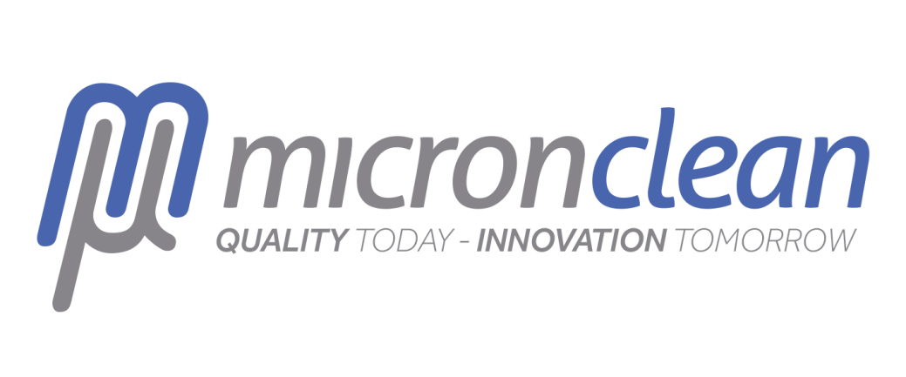
Expert Advice around Cleaning for Accommodation Providers by Micronclean

COVID-19 is having an overwhelming effect on the hospitality industry, with businesses facing a host of challenges on so many levels. The Greater Lincolnshire LEP in conjunction with Visit Lincoln has been collecting intelligence on the main challenges the sector is facing, so we can support and plan for recovery.
One of the common themes many accommodation providers have cited as a major area of concern is around cleaning. A lack of confidence in whether current cleaning methods are adequate to conquer the virus, as well as being able to instil confidence in guests when the hospitality industry re-opens are of great concern.
In response to this we have teamed up with a Lincolnshire based business Micronclean in an effort to alleviate some of these concerns.
Micronclean operate from their production sites in Skegness, Louth and Grantham. Serving many sectors Micronclean provides high grade laundry cleaning for healthcare and pharmaceutical cleanrooms, as well as specialist high grade cleaning disinfectants for medical environments. In short - these are the experts in this field!
Here are their top tips to ensure your cleaning methods are following best practice!

- SARS-CoV-2 (the virus which causes COVID-19) is an enveloped virus. This means that it is surrounded by a protective fatty layer. The best way to ‘kill’ the virus is therefore to destroy this fatty layer and the cleaning products which we would all normally use to remove fatty stains etc. are the best products to do this (i.e. soap, detergents, > 70% alcohol based products)

- The best infection control is social distancing. Most transmission occurs directly from person to person. However, there is some evidence to suggest that a small amount of transmission via surfaces may be possible. Thus, good hygiene controls are a must to reduce this transmission risk. Wash your hands regularly (20 seconds with warm soapy water, use alcohol hand sanitiser if you have it), try to avoid touching your face.

- Using a disposable cloth, wash commonly touched areas with warm soapy water (hand rails, door handles, toilet handles, taps, light switches etc.). Gloves should be worn. When finished, the cloth and gloves should be discarded in a sealed bag and you should wash your hands for 20 seconds in fresh warm soapy water.

- If an area needs to be disinfected because an individual with COVID-19 symptoms has been present, then all hard surfaces should be cleaned with disposable cloths/disposable mops, using a warm soapy detergent, followed by a dilute bleach (chlorine) solution (most commercial bleaches are 5% so should be diluted 1 in 50 with water to achieve the recommended 1000ppm of chlorine disinfectant [equivalent to 200ml in a 10L bucket]). When cleaning an area visited by a symptomatic individual, gloves and an apron should be worn.

- Items which can be laundered in a >40ºC wash should be (the highest temperature which the care label allows should be used). Plenty of detergent should be used.

- If the object cannot be laundered or surface cleaned with detergents/diluted bleach, then steam cleaning should be used.

- Electronics should be wiped cleaned with >70% alcohol products (material compatibility allowing).

- Waste from cleaning should be bagged and this bag sealed (double bagged if it cannot be sealed adequately). If possible this waste should be left for 3 days before being collected.

- For local businesses still operating, or preparing to re-open, then customers can be re-assured by putting into place higher frequency routine cleaning (‘high touch’ areas should be cleaned twice a day) and ‘in-house’ measures to ensure social distancing (clearly marked queue spacing, limiting numbers in certain areas, cleaning of card readers after every customer or adopting ‘click and collect’ models etc.).These measures should be clearly communicated to your customers.

- The best tool that can be used to combat the outbreak is maintaining social distance; risk assess how that can be achieved practically and realistically in your business. Extra cleaning will be needed, as will enhanced social distancing measures to ensure that your customers feel comfortable visiting your business.

For more information please visit www. https://www.micronclean.com/

